RIJC H3 Pharmaceutical Chemistry Preliminary Examination 2009 – Suggested Answers

1(a)(i) Sulfapyridine (sulfonamide) acts as competitive enzyme inhibitor (to the dihydropteroate synthetase enzyme), competing with the natural substrate 4-aminobenzoic acid. This leads to the disruption of the synthesis of folic acid in bacterial cells.

(ii) Human cells do not synthesise folic acid as there is no dihydropteroate synthetase enzyme in the body. Folic acid is taken as a vitamin.

(iii) Solubility of sulfapyridine decreases and crystallisation occurs within the bladder or urethra, which could lead to pain and blockage.

1(b)(i) hydrogen bonding, van der Waals forces, ionic bonds

(ii) -NH₂ group, benzene, -SO₂⁻ group

1(c)
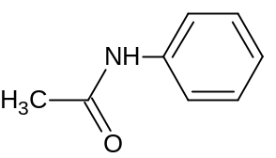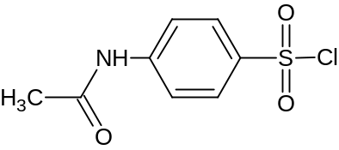
HOSO₂Cl, 80°C

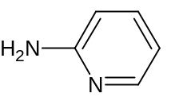

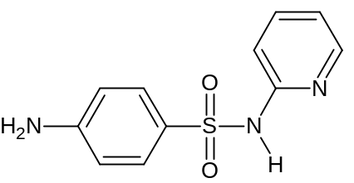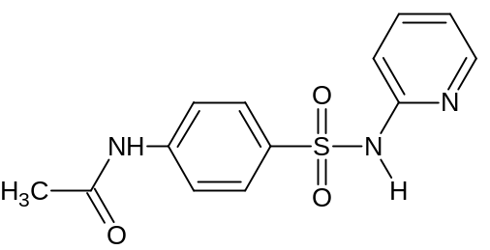
Aq. NaOH
or dilute HCl

heat

1(d)(i) -CH₃ group on aromatic ring oxidised to -CH₂OH or –COOH

(ii) oxidation of heteroatoms
de-alkylations
conjugation with sulfate, amino acids or sugars

1(e)(i) Sample mixture containing ions is placed in a gel and is separated into its constituents by applying an electric field to the gel, which is soaked in a liquid buffer.

(ii) change the buffer medium or gel support
use two-way electrophoresis in different buffers

2(a) A narcotic is a substance that depresses the activity of the central nervous system, resulting in analgesia and sleepiness, and eventually lethargy, apathy and loss of consciousness. It temporarily deactivates the nerves and blocks the pain signals.
A non-narcotic is a substance that has analgesic, antipyretic and anti-inflammatory activity, and it does not bind to the opiate receptors. Instead, it binds directly to the pain receptors and prevents them from responding normally to pain stimuli.
Morphine and heroin are narcotic drugs while aspirin and paracetamol are non-narcotic drugs.

2(b) An agonist is a drug which mimics the natural ligand of a particular receptor. The agonist binds to the receptor and produces a similar biological/ pharmaceutical response.

2(c)
peak | wavenumber/ cm^{–1} | functional group
A | 3400 | O–H (alcohol/ phenol)
B | 2850 | C–H (alkane/ alkene/ arene)
C | 1610 | C=C (alkene)

The ester C=O stretching, which is associated with aspirin, is absent.
Hence, the drug in the sample has to be morphine.

2(d) concentrated HI, heat

2(e) Both aspirin and paracetamol have analgesic and antipyretic activity. However, aspirin inhibits COX-1, an enzyme which ensures that the stomach lining is thick enough to prevent the acid in the stomach from reaching the cells carrying the blood supply. Therefore, aspirin may cause the peptic ulcers to recur. Paracetamol, on the other hand, does not inhibit COX-1. Thus, consuming paracetamol can reduce the body aches, cause the fever to subside and lower the probability of the recurrence of the peptic ulcers.

2(f) At 240 nm, 0.433 = 1.0(10^{3.55}c_{aspirin} + 10^{4.01}c_{paracetamol}), c_{i} = concentration of substance i
At 280 nm, 0.096, = 1.0(10^{2.80}c_{aspirin} + 10^{3.41}c_{paracetamol})
c_{aspirin} = 4.92 x 10^{–5} mol dm^{–3} (3 sf)
c_{paracetamol} = 2.53 x 10^{–5} mol dm^{–3} (3 sf)
c_{paracetamol} < c_{aspirin}, so paracetamol is metabolised faster
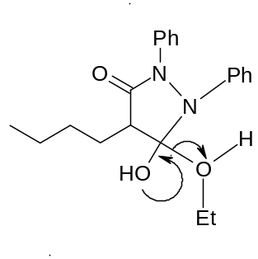
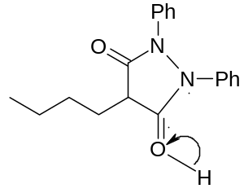
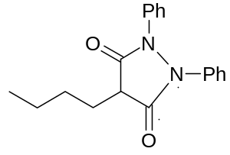
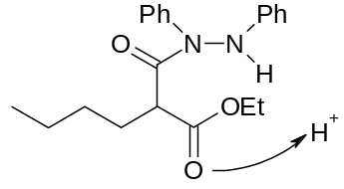
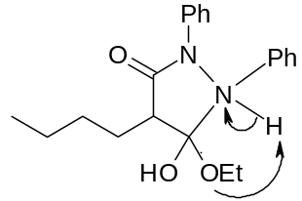
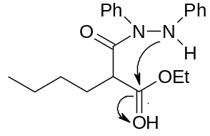
+

+
– EtOH
– H⁺

+

+
2(g)

2(h)(i) Naloxone is an antagonist which competes with Demerol® to bind at the same receptor site; it does not provoke a biological response like Demerol® does. Administering naloxone will partially reverse the binding of Demerol® to the receptor site and reduce the harmful effects (e.g. cardiac arrest) brought about by the overdose of Demerol®.

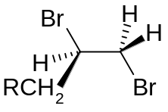
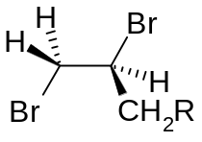
2(h)(ii)
S
R
1
2
3
1
2
3

If the three groups of higher priority are arranged in a clockwise fashion (from 1 to 3) such that the hydrogen atom goes into the paper, the configuration of the chiral carbon is R. If they are arranged in an anticlockwise fashion (from 1 to 3), the configuration of the chiral carbon is S.

3(a)(i) hallucinogens
any of the following: affect thought and perception, produce visual hallucinations, flashbacks of past experiences

3(a)(ii) Phencyclidine is metabolised into other products almost completely, hence the urine sample would contain only the metabolites and not the actual drug.

3(b)(i) An antagonist is a drug that docks well at the binding site but does not create the required change of shape of the receptor.

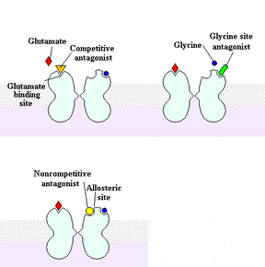
3(b)(ii)

any one of the three diagrams:
binding of phencyclidine at glutamate, glycine or allosteric site
closing of channel
3(c)(i) The species responsible for the peaks at m/z values 146 and 161 are:
m/z | Species responsible | Deduction
146 | 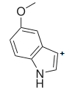 | Loss of 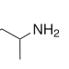
161 | 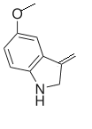  + | Rearrangement to lose CH₂=CHNH₂

3(c)(ii) compound I

any one of the following:
m/z | Species responsible | Deduction
189 (M⁺ - 15) | 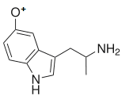 | Loss of methyl – methyl group present
44 | [CH(NH₂)CH₃]⁺ | -CH(NH₂)CH₃ present
77 (absent) | C₆H₅⁺ (absent) | More than one cleavage required to produce C₆H₅⁺
105 (absent) | C₆H₅CO⁺ (absent) | C₆H₅CO absent
99 (absent) | 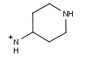 (absent) | 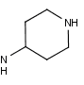 absent

33(d)(i) an aromatic bicyclic system consisting of pyrrole and benzene / indole
–CH₂CH₂– chain linking the bicyclic system and the amine
a tertiary amine

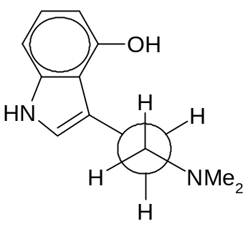3(d)(ii)

There is minimum steric repulsion between the bicyclic system and the N,N-dimethylamino group in the most stable conformer as they adopt an anti- (staggered) conformation.

3(d)(iii)To a small portion of each compound, add benzenesulfonyl chloride (C₆H₅SO₂Cl), followed by NaOH(aq). Acidify with HCl(aq). A precipitate is observed for 5-HT, but no precipitate is observed for psilocin.
[Alternative: To a small portion of each compound, add an aqueous solution of ninhydrin and heat. The solution turns blue/ purple only with 5-HT.]

(d)(i) an aromatic bicyclic system consisting of pyrrole and benzene / indole
–CH₂CH₂– chain linking the bicyclic system and the amine
a tertiary amine

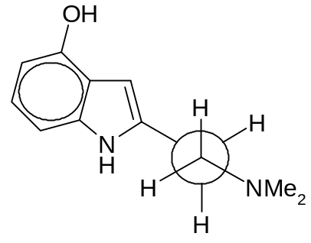3(d)(ii)

There is minimum repulsion between the bicyclic system and the N,N-dimethylamino group in the most stable conformer as they adopt an anti- conformation.

3(d)(iii)To a small portion of each compound, add benzenesulfonyl chloride (C₆H₅SO₂Cl), followed by NaOH(aq). Acidify with HCl(aq). A precipitate is observed for 5-HT, but no precipitate is observed for psilocin.

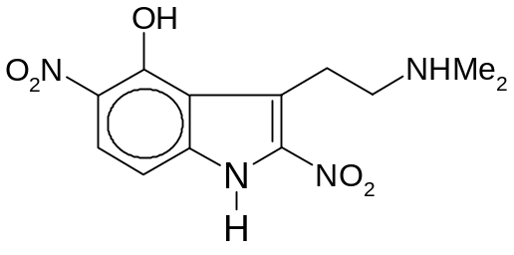
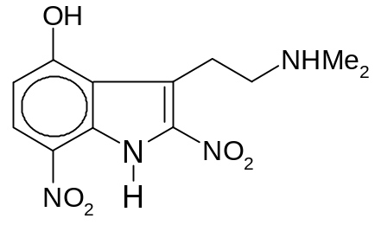
3(e)(i)
+
NO₃–
+
NO₃–

or

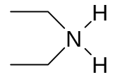
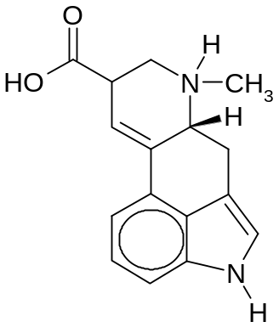
(ii)
+
Cl–
+
Cl–
–

and

4(a) Both phenolic groups and hydroxyl group at position 2 are involved in the binding of noradrenaline to adrenergic receptors.

4(b)(i) The positively charged nitrogen interacts with the carbonyl oxygen (see diagram).
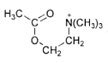
The electron-withdrawing effect makes the carbonyl carbon more electron deficient and susceptible to nucleophilic attack.

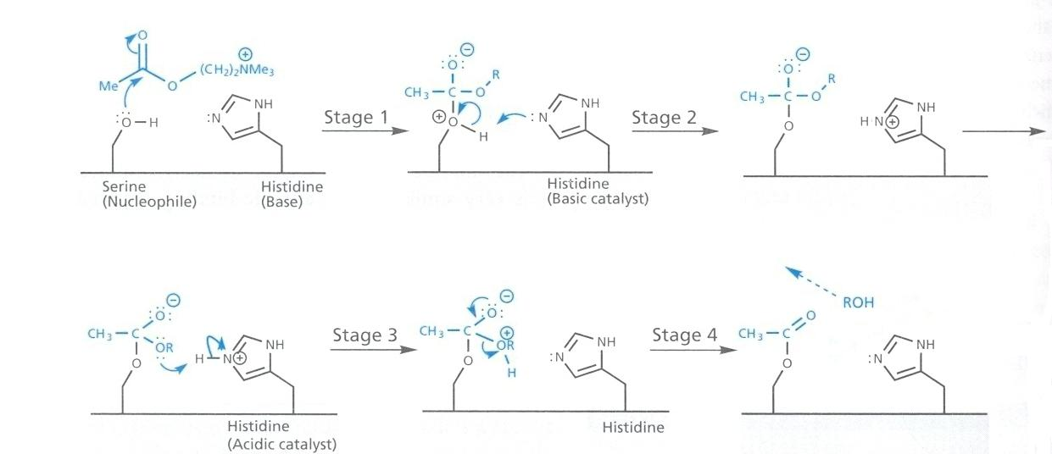

4(b)(ii)

4(c)(i) Stereoisomers have similar functional groups and hence IR spectroscopy cannot differentiate the isomers. However, NMR could be used as the chemical environment of protons in stereoisomers could be different.

4(c)(ii)
Observation | Deduction
5 peaks | 5 different groups of protons
quartet and triplet set of area 2:3 | ethyl group present
peaks around 7 ppm | benzene group present  Since X is a cocaine derivative, it could contain a benzoate group.
singlet around 4 ppm | could belong to an amino group
The structure is ethyl 4-aminobenzoate.
4(d) withdrawal symptom
In the presence of caffeine, the action of neurotransmitters / natural ligands at the binding sites is inhibited. The cells respond by making more receptors to increase the sensitivity to the ligands. If caffeine intake is withdrawn, the cells receive a larger than normal response , thus triggering withdrawal symptoms.

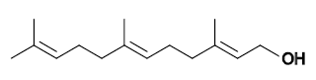
4(e)

E
E

5(a) inhibition of the synthesis of viral nuclei acids
inhibition of viral protein synthesis

5(b) The liver metabolises the drug to such an extent that only a small amount of active drug emerges from the liver to the rest of the circulatory system.

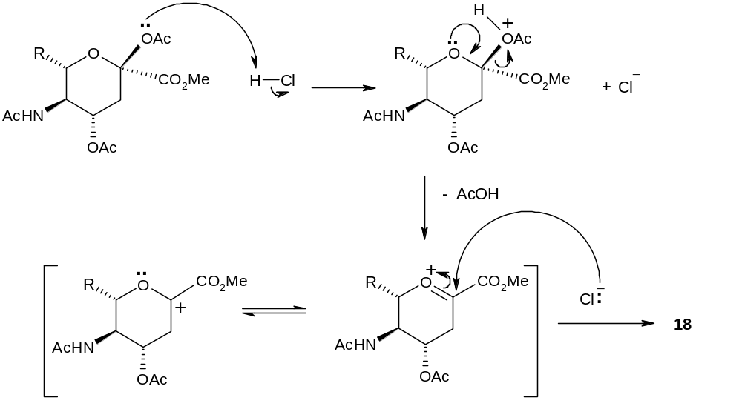5(c)(i)

3

5(c)(ii) Carbocation formed is stabilised by resonance with oxonium ion (from electron donation of ring oxygen), therefore loss of AcOH is feasible and hence S_{N}1 is possible. For other AcO groups, loss will result in carbocation that is not stabilised as oxonium ion, hence the S_{N}1 reaction is not possible.

5(c)(iii)
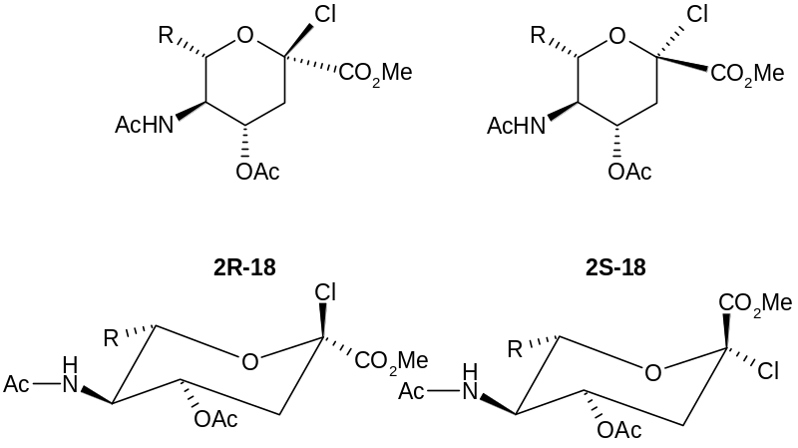

The R, AcNH and OAc groups on C6,C5, C4 respectively should be equatorial.

5(c
(iv) E2 mechanism, requires Cl to be transdiaxial to H on the C3, hence Cl should be axial and 2R-3 is suitable.

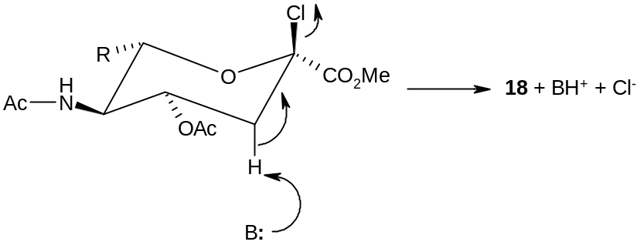

3 + BH⁺ + Cl–

E1 is not accepted as a base is required and the reaction follows 2nd order kinetics (although, E1 is likely since the oxonium ion is stable.)

5(d) BF₃ is used to make AcO a better leaving group/ activate AcO by complexing to the O and pulling in electron density.

Note: S_{N}1 mechanism is also accepted, i.e. loss of AcO-BF₃ to create a carbocation C⁺ at C4, followed by attack of =O: nucleophile on the C⁺. The carbocation is allylic and will be stable. Stereochemistry will still be the same since the =O: nucleophile has to come from the top.

5(e) nucleophilic substitution (DPPA acts like SOCl₂, where the azide groups N₃– behaves as a pseudohalogen)

5(f) Step g: DPPA reacts with any –OH group to give azide.

Hence, it is important to protect all the other –OH groups and –COOH groups by carrying out steps a and b first. In these steps, all the –OH and –COOH groups are converted to esters.

5(g) Monoclonal antibodies are antibodies that have “been” cloned from one particular type of B lymphocyte.
They are used in two situations.
1. If the antigens of the invading virus do not correspond to any of the antibodies that the body’s B lymphocytes can produce, no immune response can be triggered.
2. If the body’s immune system is already under strain, there may not be enough “reserves” in the system to enable the production of the antibody to be stepped up sufficiently.

6(a)(i) NAD⁺ is an aromatic compound.
NAD⁺ is has 2(1)+2 = 6π electrons delocalised in a ring
NADH is a non-aromatic compound.
The presence of sp³ C atom breaks the conjugation.

6(a)(ii)
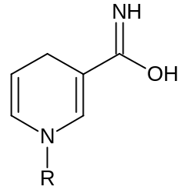

6(a)(iii)
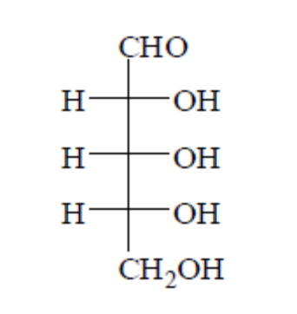

6(b)(i)
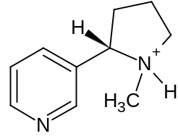

6(b)(ii) For pyrrole, the nitrogen atom donates both electrons in its lone pair to the delocalised π bond. Because of the non-availability of the nitrogen atom’s lone pair of electrons, pyrrole is a weaker base compared to the N-1.

6(c)(i) Use NMR spectroscopy.
It will detect the different number of H’s attached to the ring.
The first compound has 4 aromatic peaks (each 1 H) while the second compound has 3 alkene peaks (each 1 H) and 1 aliphatic peak (2 H).

6(c)(ii) Use IR spectroscopy
The first compound has a peak at 1680-1750 cm^{–1} due to C=O bond. The second compound has no peak in that region.
6(d)(i)
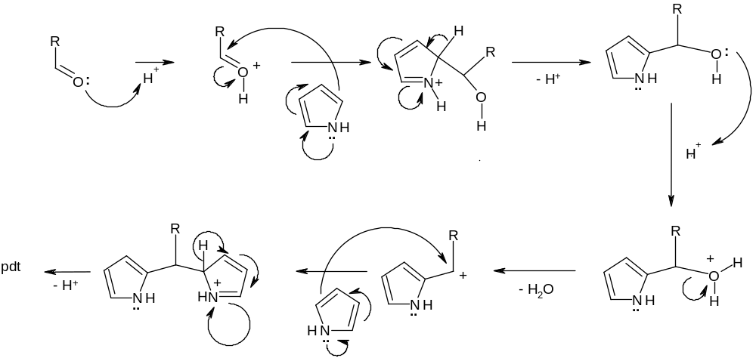
step 1
step 2

S_{N}1 type substitution preferred for step 2 since the carbon is rather hindered with two attached rings. C⁺ is also stabilised via resonance with pyrrole and benzene.

6(d)(ii) dehydrogenation

